This ACE Technical Document is intended for ACE representatives only. It was created to present the ACE philosophy and help further the understanding of the technical aspects of the selective soldering process when discussing ACE products with a client.

**Nitrogen Requirements**

Nitrogen is a required and necessary consumable with all selective soldering machines for the following reasons.

* Without nitrogen, the solder tends to bridge and form icicles. Nitrogen reduces the surface tension allowing the molten solder to break away from the solder site.
* In an open atmosphere, dross formation is increased, requiring more frequent cleaning and pump maintenance. Nitrogen displaces the air, helping minimize the formation of dross.
* The solder nozzle will not remain “tinned” causing the solder wave to deteriorate. Solder wave stability is increased when using nitrogen.

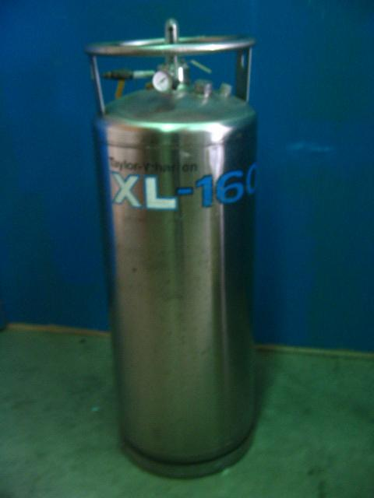The most economical way to purchase nitrogen for a part time-single shift operation is in liquid form. Pressurized gas tanks like welding tank size do not have much capacity and will last only hours. Industrial gas suppliers can provide a liquid tank called a Dewar. The vendor can set a routine exchange schedule, often with same day delivery. When ordering, gas specify 99.999% purity. The provider should have documentation to validate the purity. These tanks are safe for open floor use. It will need a pressure regulator with a ¼” female NPT fitting to our machine. The tank will supply approximately 3600 cubic feet of nitrogen. The average machine consumes about 15/50 so the Dewar tank will supply about 2-4 weeks of nitrogen for a single shift operation.

If the Wave nozzles or the “dual nozzle” setup are used, or a higher duty than 30 hours a week is expected, it is probably more economical to purchase a nitrogen generator. These are the best choice for unlimited, pure nitrogen. The generators have an output flow regulator to set gas purity and flow rate in SCFH and a readout of the exact purity.